

**Department of Electronic & Telecommunication Engineering**

**University of Moratuwa**

**EN2570 – Digital Signal Processing**

**FIR Filter Design – Band pass Filter**

**Name Index number**

M.W.K.S.Jayalath 180260U

This report is submitted in partial fulfillment of the requirements for the

EN2570 – Digital Signal Processing

**ABSTRACT**

This report outlines the design process of a Non - Recursive (Finite Impulse Response)

Bandpass Filter using the Kaiser Window Function. MATLAB 2017b software package was

used as the programming environment for the design project. In the following sections the

basic theoractical construct underlying te design process, results obtained and the conclusion

would be discussed.

Keywords - Non Recursive (FIR) Bandpass Filter, KaiserWindow Function, MATLAB 2017b

software package

**INTRODUCTION**

This report discusses one major method used in designing Non – Recursive FIR filters named Fourier Series Method (Window Method). In this method the fourier series concept is used along with a class of functions called window functions which are used to achieve the finite property of the filter while preserving desired features. There are multiple windows which can be used to achieve the task of creating the filter and this report is based on the use of Kaiser Window.

**BASIC THEORY IN BRIEF**

The ideal band pass filter would be the filter with 1 as the gain (in linear scale) in the pass band and 0 as the gain in stop band. Assuming the existence of a filter with above properties we can obtain its time domain representation, which is the impulse response of an ideal band pass filter.

This impulse response becomes a signal with an infinite number of samples (through observation). Thus to create a Finite Impulse Response system we make use of a window function. A window function is used to extract a specific window of the ideal impulse response by zeroing out the other samples which falls outside the window. This is obtained by multiplying the ideal impulse response (designed for the required filter specifications) by window function in time domain. This corresponds to a convolution in the frequency domain.

The simplest window function is a rectangular window whose fourier representation is a ‘sinc’ function.

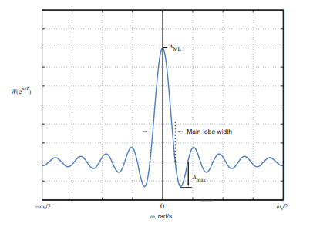

There are controllable parameters in these window functions which allows us to adjust the window to suit our application. Main lobe width and ripple ration of the window are key parameters which decide the quality of the filter derived using this window.

Kaiser window is an advanced window than the regular window and is much more accurate. It has characteristic curves,

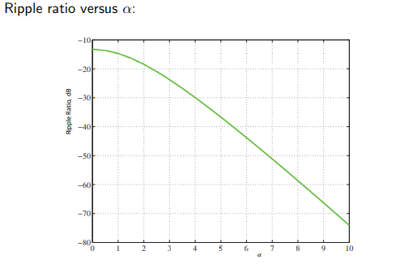

For the filter to be closer to the ideal situation, ripple ratio should be minimum. According to above curve, Kaiser Window provides us an additional parameter α, that can be used to shape and adjust the filter.

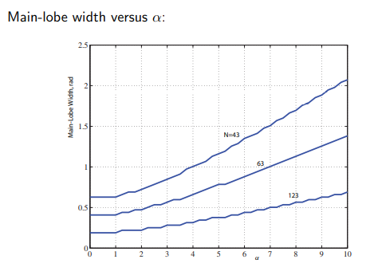

For an ideal-like filter, main lobe width of the window should be low (for the transition bandwidth to be narrow). Increasing parameter α favors in ripple ratio but its unfavorable regarding main-lobe width. Thus we have another parameter, window size (N) which can be used to shape the filter.

Thus using the Kaiser Window, the filter parameters can be adjusted better than the rectangular window.

Following is the stepwise design procedure of a band pass filter when required parameters are specified,

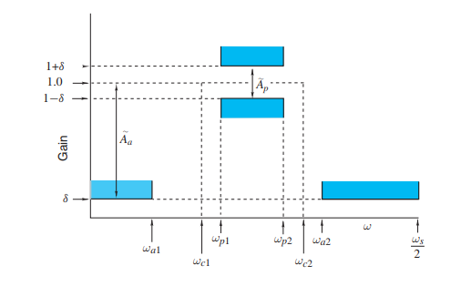

Symbols in the above diagram,

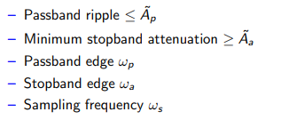

STEP 1:

Between the two transition bands (between stop band edge and pass band edge on low side and on high side), select the minimum transition band width as the transition bandwidth for the filter. Having a narrower transition bandwidth makes the filter a better approximation to the ideal situation.



STEP 2:

Higher and lower cut off frequencies of the pass band can be derived as follows,



Here the higher and lower pass band edge frequencies are requirements of the given filter specifications

STEP 3:

Deriving impulse response for the ideal filter situation,

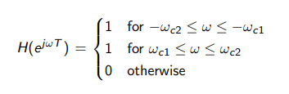

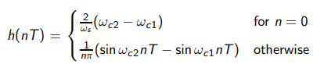

Sampling frequency is a specified requirement of the filter design.

STEP 4 :

Determining the specified tolerance parameters for pass band and stop band and deriving tolerance parameter (delta) for the filter using them

Specified tolerance limit for pass band,

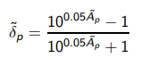

Specified tolerance limit for stop band,



Ap and Aa are parameters specified accoridng to the requirements of the filter application.

Actual tolerance limit for the filter,



STEP 5 :

Due to above derivation of tolerance limit, actual value for stop band attenuation might deviate from the specified parameter ‘minimum attenuation for the stop band’. We should calculate the actual value as follows (in dB),



STEP 6 :

Except for the window size parameter, kaiser window has another independent parameter α which can be derived using the actual stop band attenuation value derived in step 5.

chose α as follows,

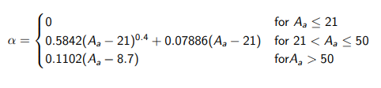

STEP 7 :

Next step is deriving ‘D’ parameter which is an intermediate oarameter defined prior to deciding window size (N)

Chose D parameter according to the following criteria,

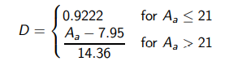

STEP 8:

Deciding window size (N),

N is selected to be the lowest odd integer which satisfy the following inequality,



STEP 9:

Deriving the Kaiser Window Function as follows,

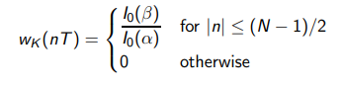

Where,

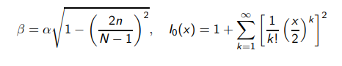

STEP 10:

Finally obtain the modified transfer function using the derived window.



**RESULTS**

Filter specifications,

|  |  |
| --- | --- |
| Parameter | Value |
| Maximum pass band ripple | 0.09 dB |
| Minimum stop band attenuation | 52 dB |
| Lower stop band edge | 850 rad/s |
| Lower pass band edge | 1000 rad/s |
| Upper pass band edge | 1400 rad/s |
| Upper stop band edge | 1500 rad/s |
| Sampling frequency | 3800 rad/s |

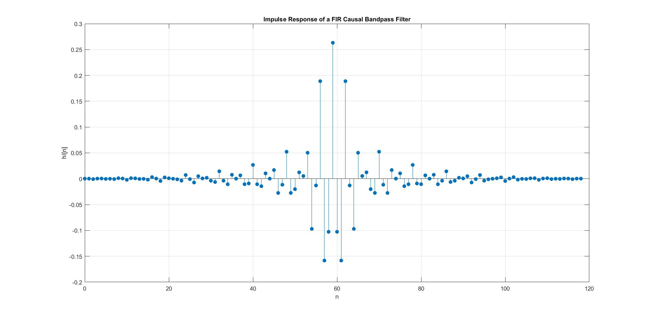

Causal Impulse Response

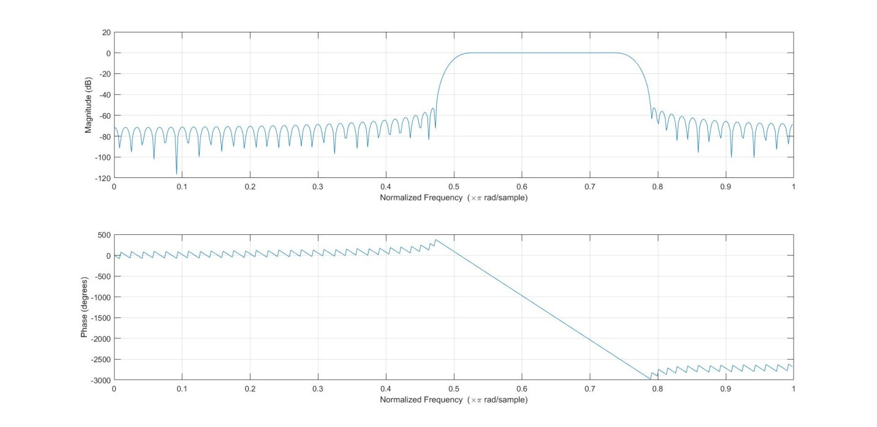

Magnitude and Phase Response (in discrete frequencies)

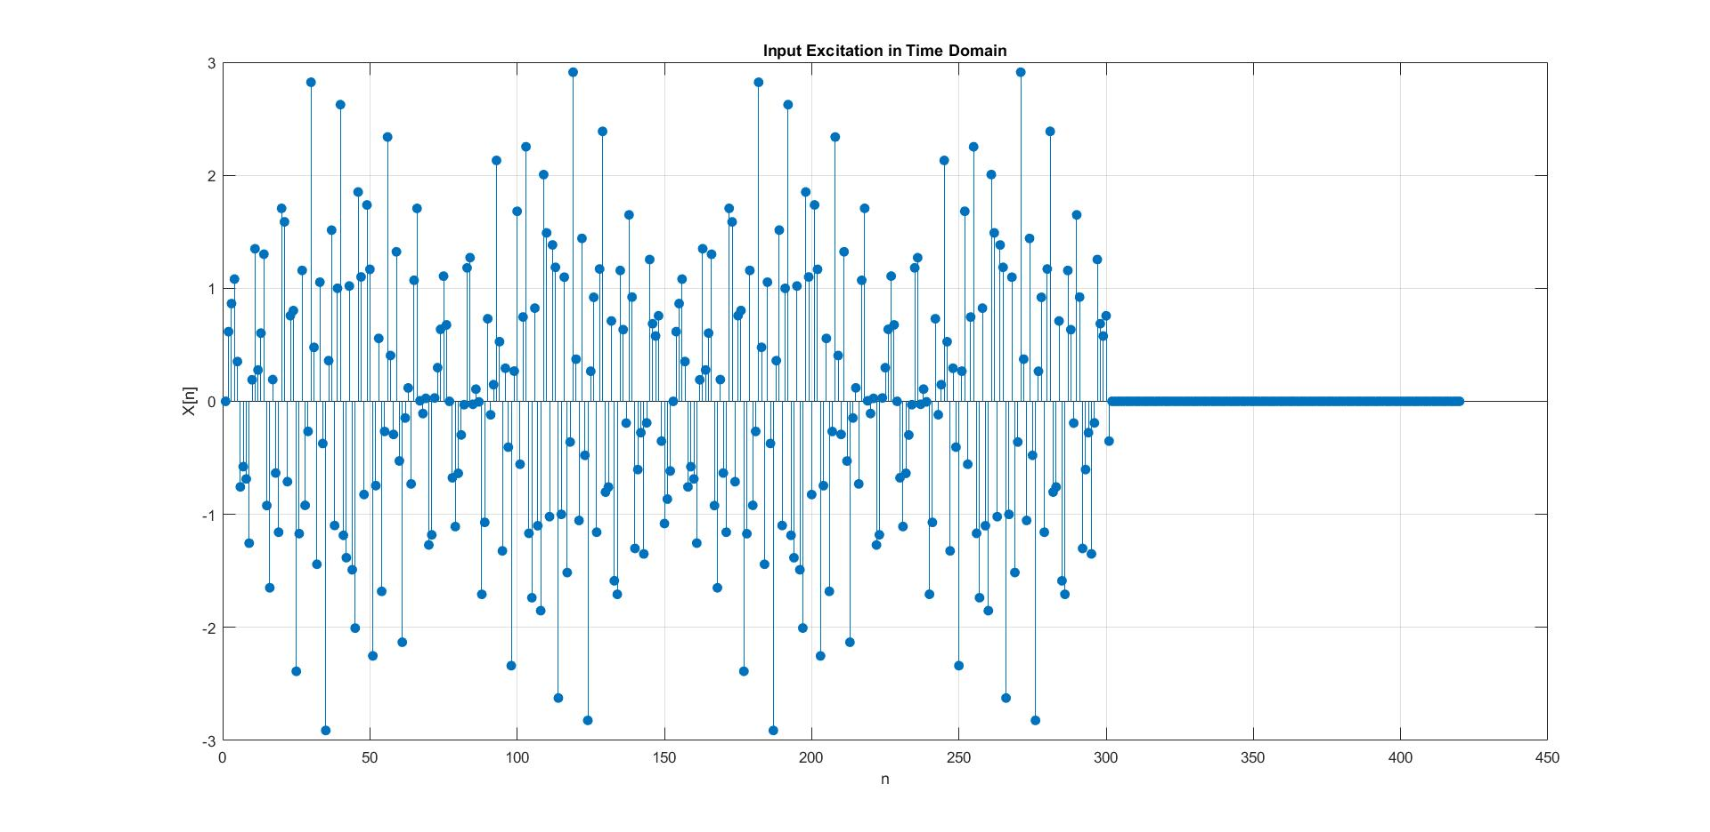

Input Excitation in Time Domain

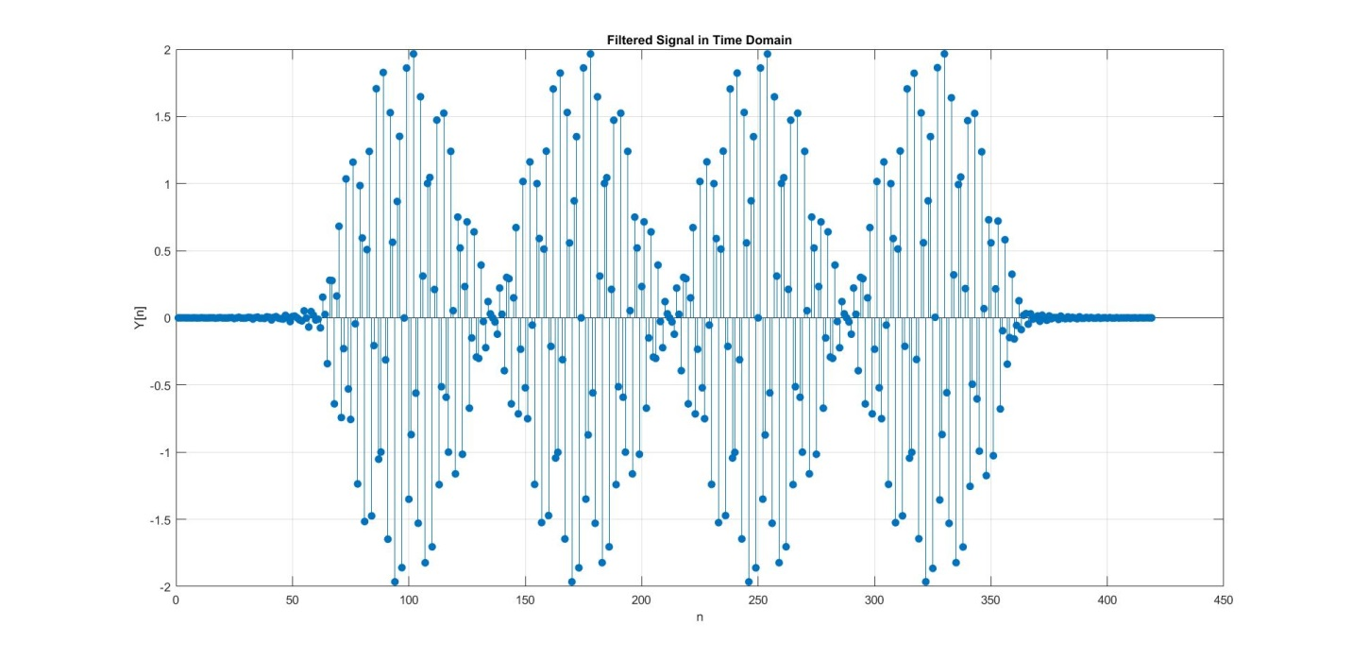Filtered Signal in Time Domain

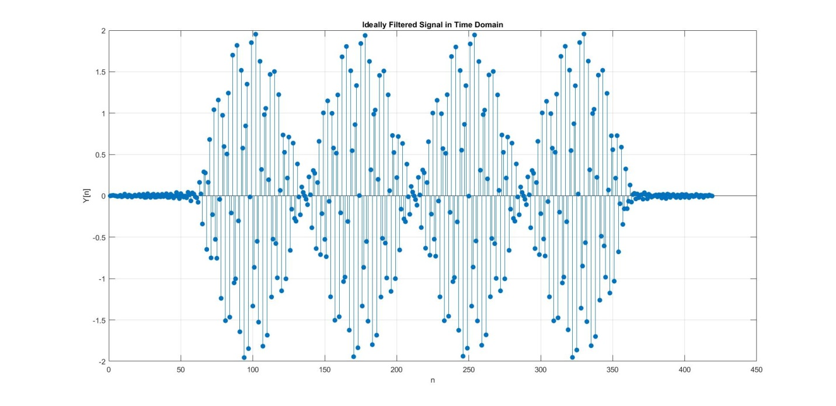

Ideally Filtered Signal in Time Domain

**CONCLUSION**

The Kaiser Window based band pass filter was successfully implemented for the given filter specifications.

**ACKNOWLEDGEMENTS**

My sincere gratitude extends towards Dr.Chamira Edussooriya for the valuable guidance and support.

**REFERENCES**

Digital Signal Processing: Signals, Systems, and Filters 1st Edition by Andreas Antoniou